Calculus Review

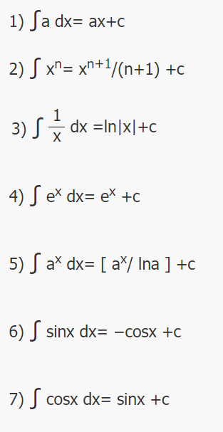 | 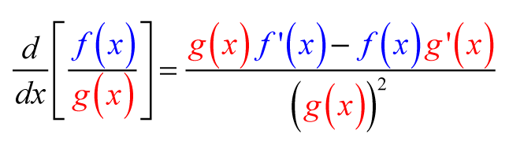
 | 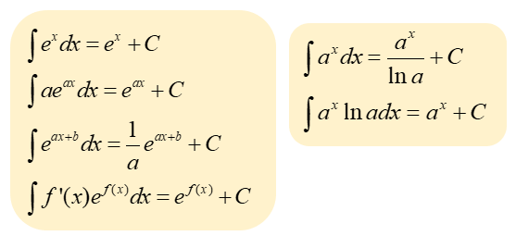

Regularization
Regularization refers to techniques that are used to calibrate machine learning models in order to minimize the adjusted loss function and prevent overfitting or underfitting.
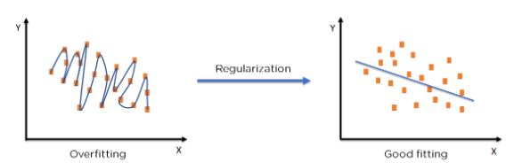

Using Regularization, we can fit our machine learning model appropriately on a given test set and hence reduce the errors in it.
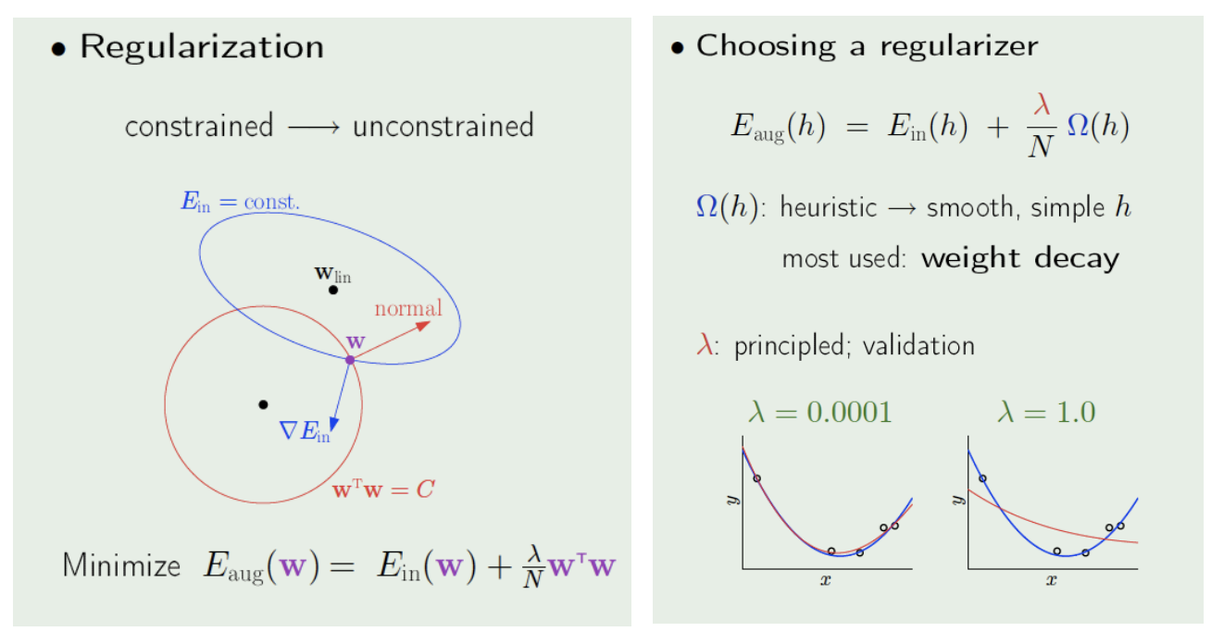
Early stopping can be used as a regularizer.
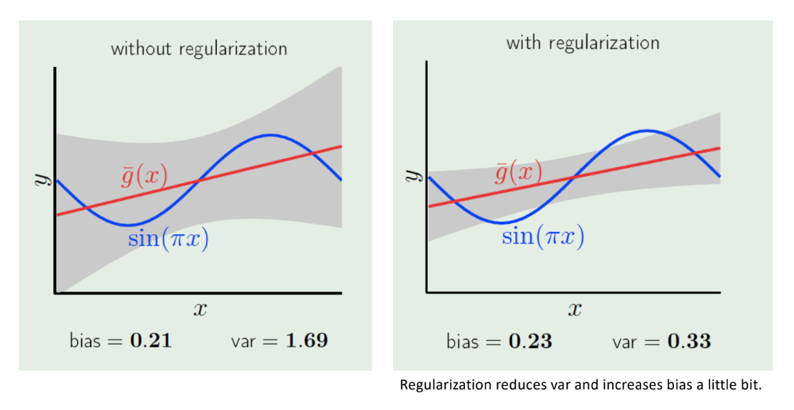
- Low Bias: A low bias model will make fewer assumptions about the form of the target function.
- High Bias: A model with a high bias makes more assumptions, and the model becomes unable to capture the important features of our dataset. A high bias model also cannot perform well on new data.
Ways to reduce High Bias:
High bias mainly occurs due to a much simpler model. Below are some ways to reduce the high bias:
- Increase the input features as the model is under fitted.
- Decrease the regularization term.
- Use more complex models, such as including some polynomial features.
Ways to Reduce High Variance:
- Reduce the input features or number of parameters as a model is overfitted.
- Do not use a complex model.
- Increase the training data.
- Increase the Regularization term.
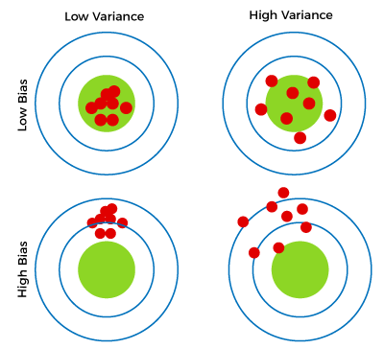

Validation
The idea of a validation set is almost identical to that of a test set. V\Te remove a subset from the data; this subset is not used in training. We then use this held-out subset to estimate the out-of-sample error. The held-out set is effectively out-of-sample, because it has not been used during the learning.
However, there is a difference between a validation set and a test set. Although the validation set will not be directly used for training, it will be used in making certain choices in the learning process. The minute a set affects the learning process in any way, it is no longer a test set. However, as we will see, the way the validation set is used in the learning process is so benign that its estimate of Eout remains almost intact.

Validation Set
Validation dataset can be used for tuning hyperparameters, model selection or early stopping.

Cross Validation
Cross-validation is a technique in which we train our model using the subset of the data-set and then evaluate using the complementary subset of the data-set.

The three steps involved in cross-validation are as follows :

- Reserve some portion of sample data-set.
- Using the rest data-set, train the model.
- Test the model using the reserve portion of the data-set.

K-Fold Cross Validation
In this method, we split the data-set into k numbers of subsets (known as folds) then we perform training on all the subsets but leave one (k-1) subset for the evaluation of the trained model. In this method, we iterate k times with a different subset reserved for testing purposes each time.

Support Vector Machines
http://macheads101.com/demos/svm-playground/
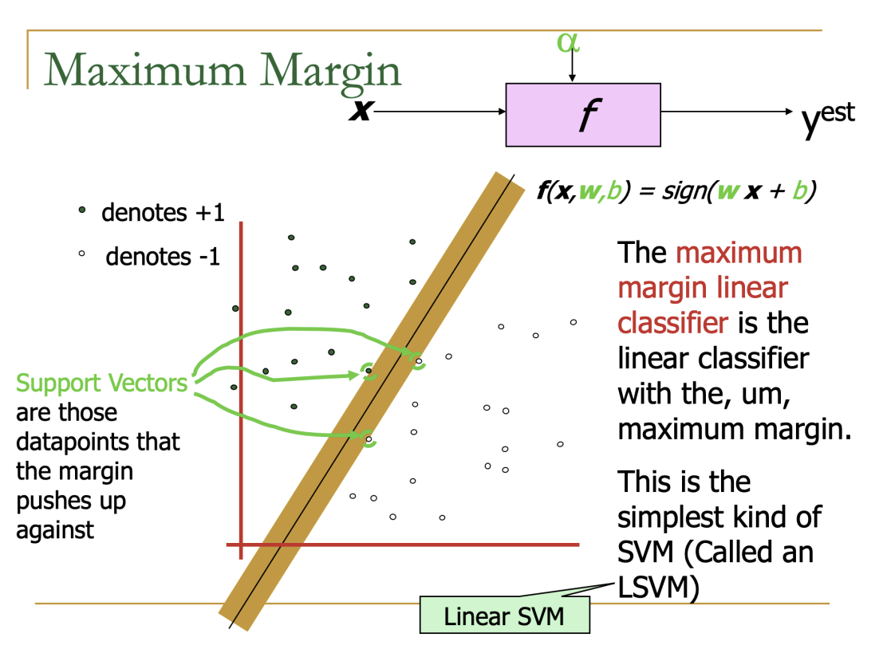
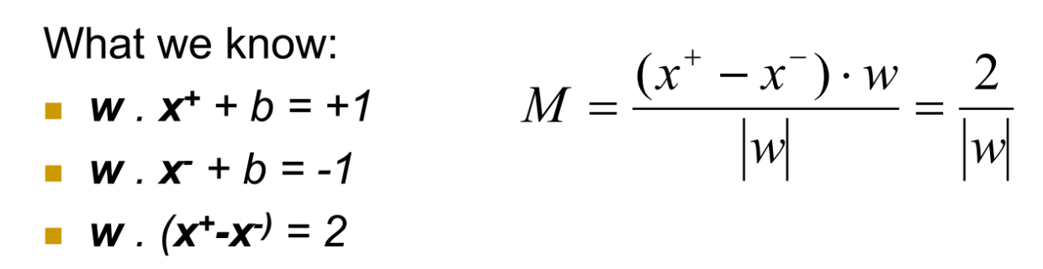
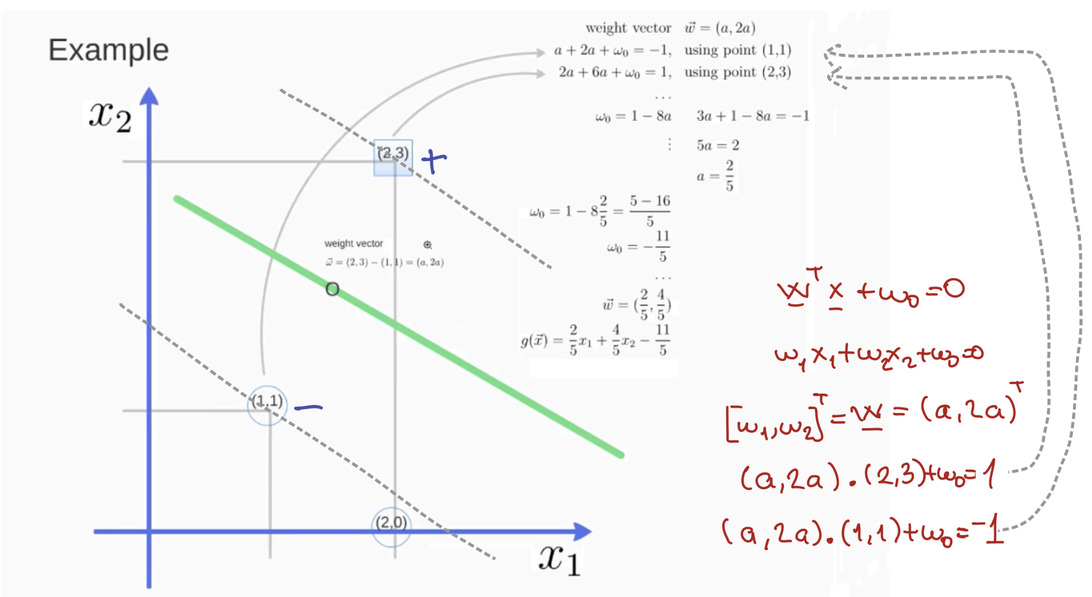

Soft margin classification
Slack variables ξi can be added to allow misclassification of difficult or noisy examples.
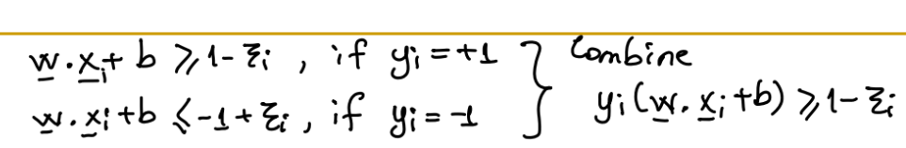

Non-linear SVMs

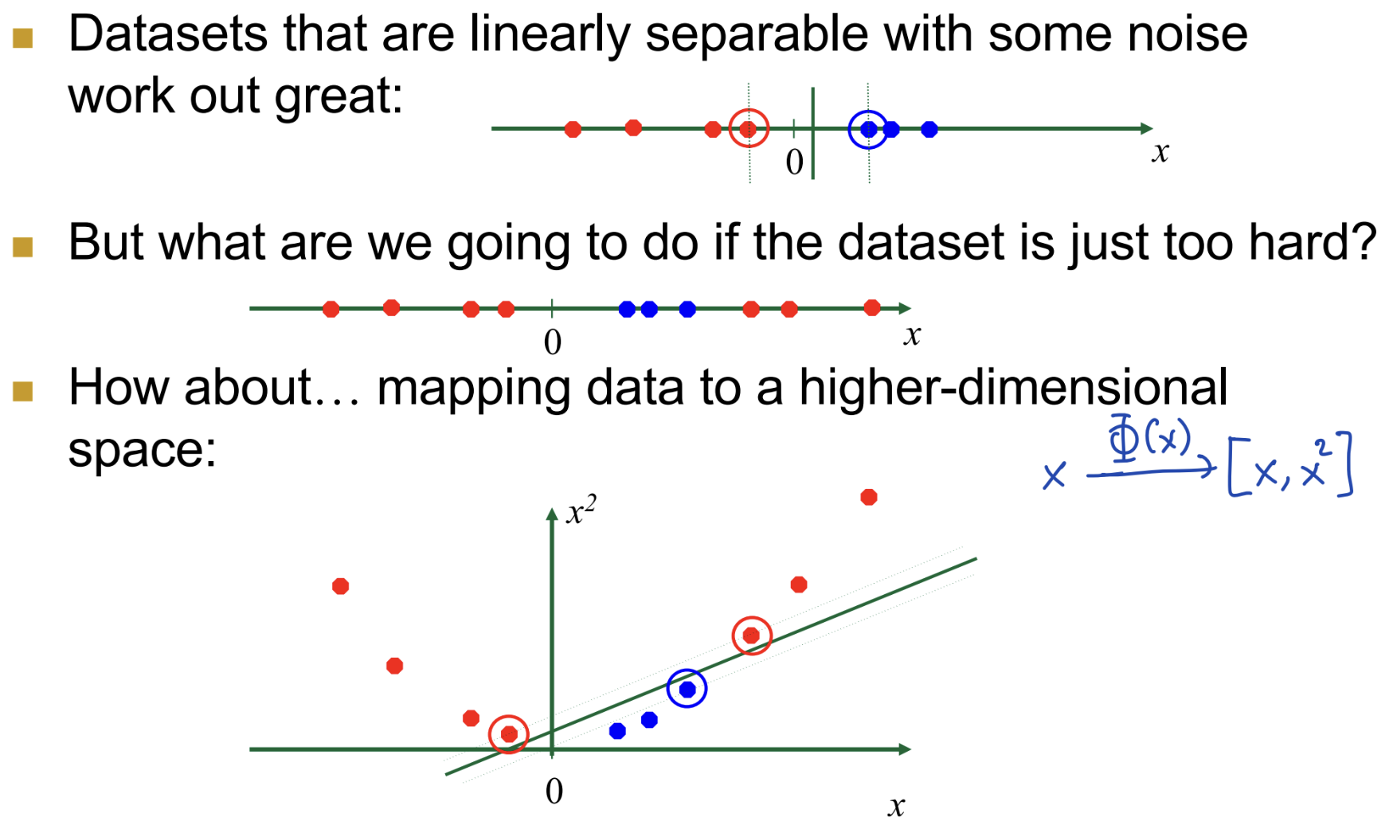
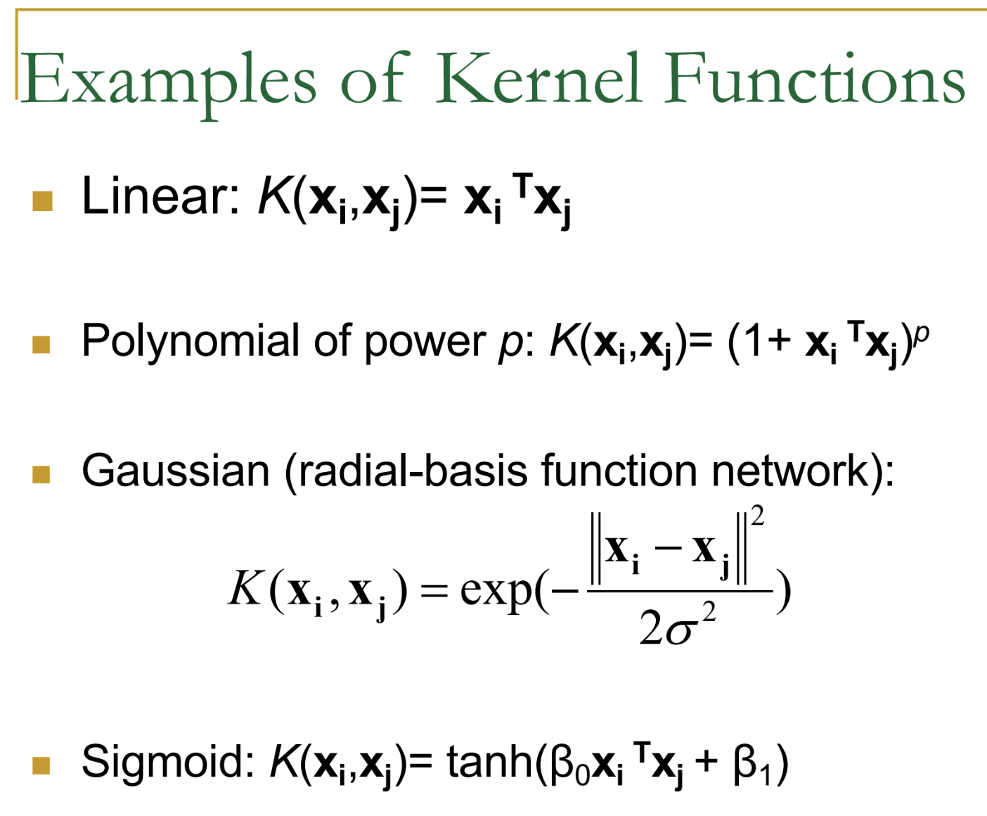
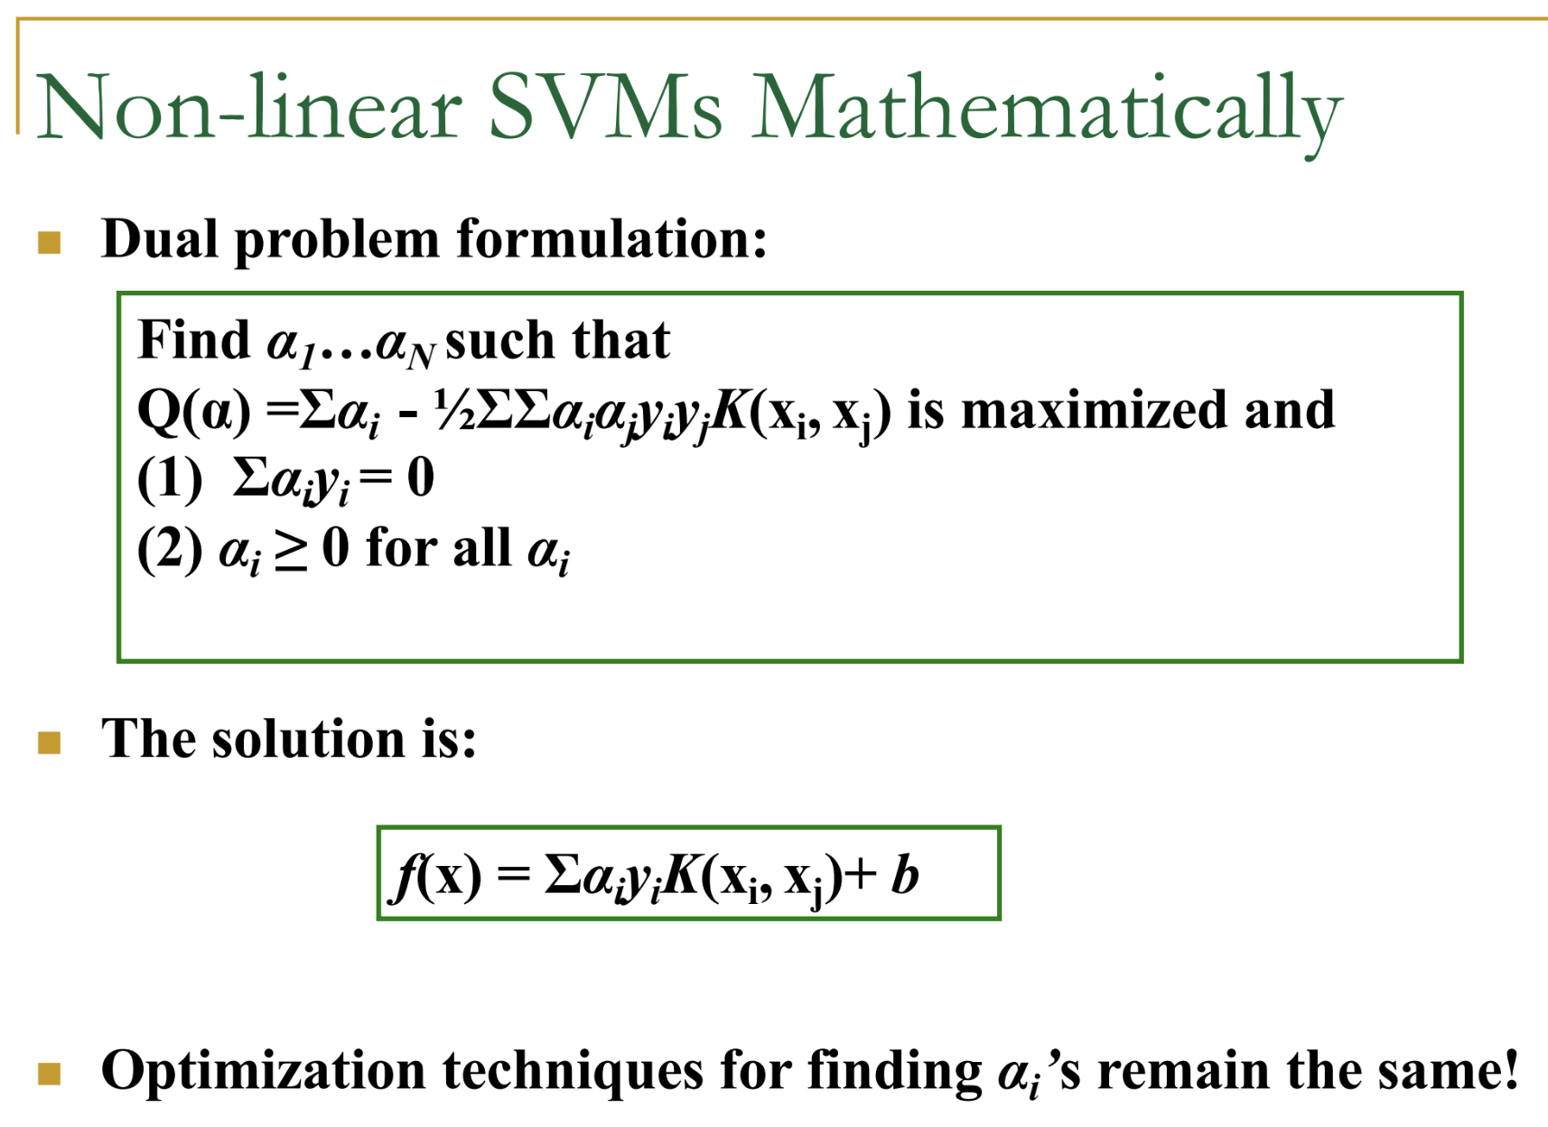
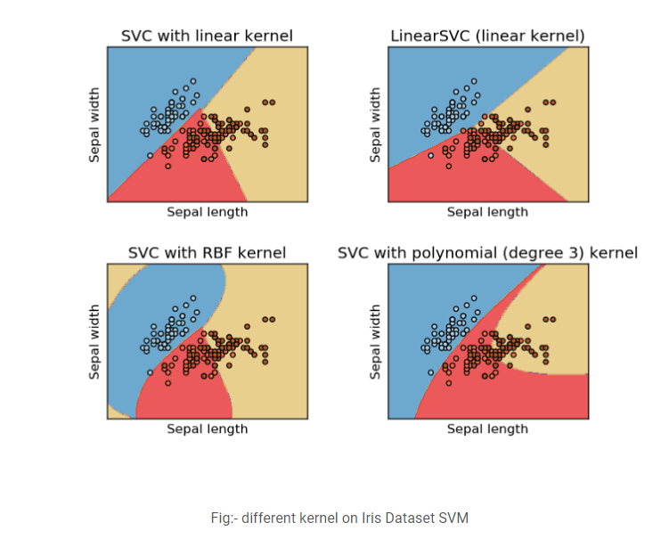

Properties of SVM
- Flexibility in choosing a similarity function
- Sparseness of solution when dealing with large data sets
  - only support vectors are used to specify the separating hyperplane
- Ability to handle large feature spaces
  - complexity does not depend on the dimensionality of the feature space
- Overfitting can be controlled by soft margin approach
- Nice math property
  - a simple convex optimization problem which is guaranteed to converge to a single global solution

Weaknesses of SVM
- It is sensitive to noise
  - A relatively small number of mislabeled examples can dramatically decrease the performance
- It only considers two classes (we can use multiple SVMs for multi-class classification)

SVM Applications
- Text categorization
- Image classification
- Bioinformatics (protein classifications)
- Hand-written digits recognition

Bayesian Decision Theory

Bayes Theorem
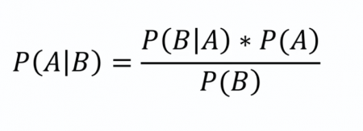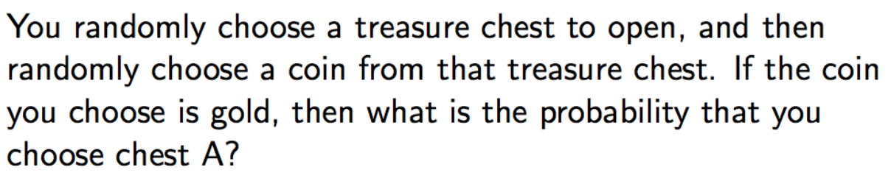

$(1/2*1)/(1/2*1)*(1/2*1/2)=2/3$
Bayesian Decision Theory is a fundamental statistical approach to the problem of pattern classification. It is considered as the ideal pattern classifier and often used as the benchmark for other algorithms because its decision rule automatically minimizes its loss function.
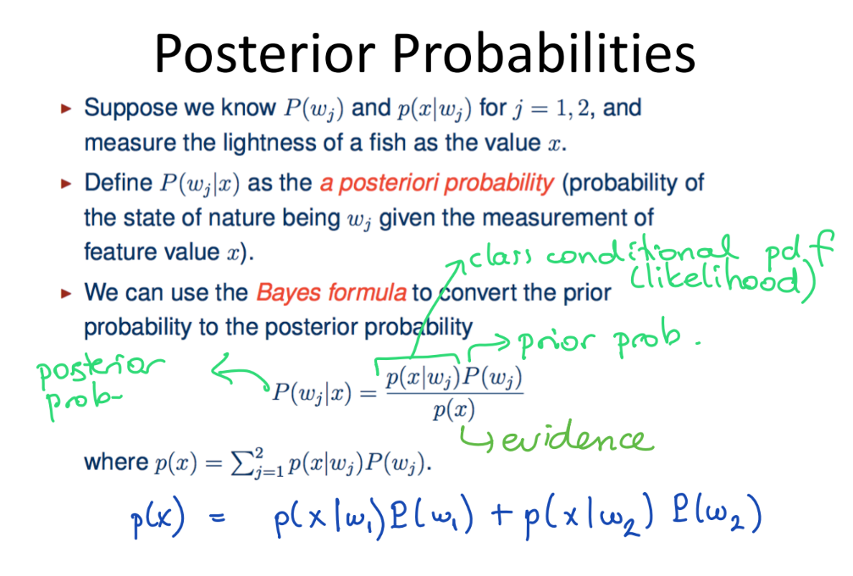
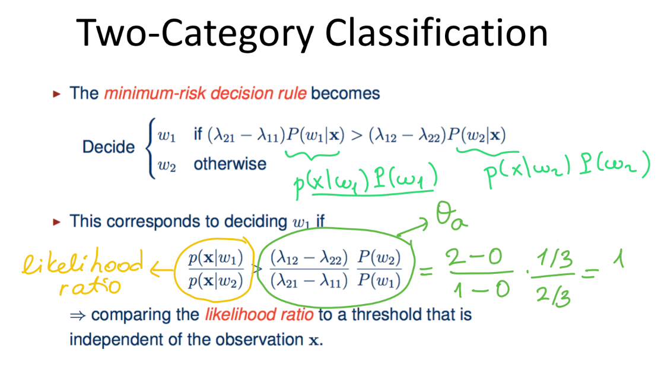
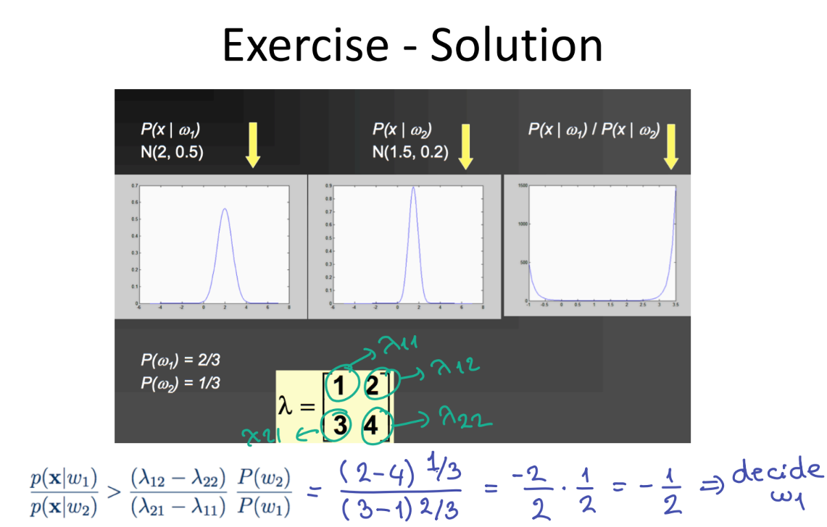
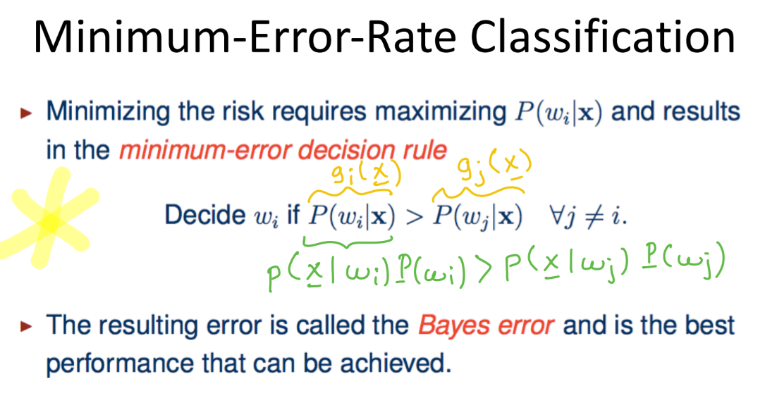
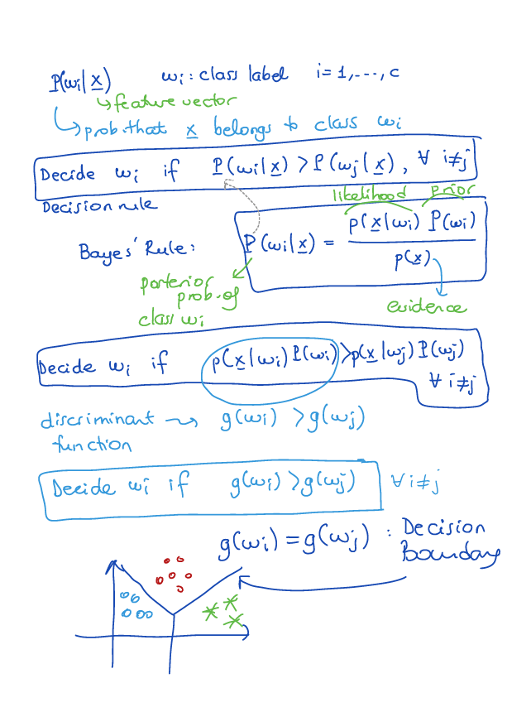
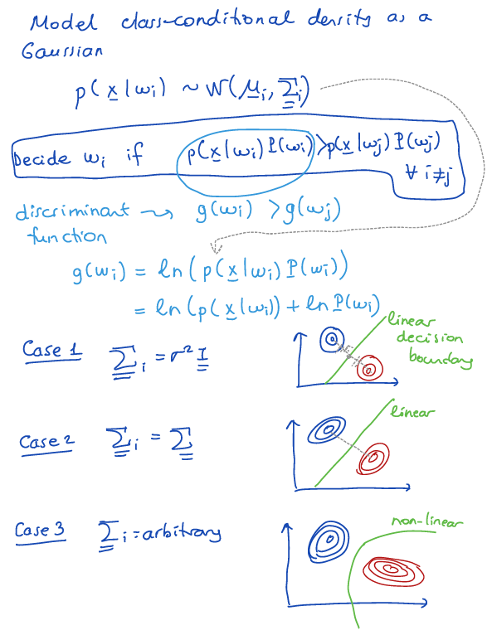
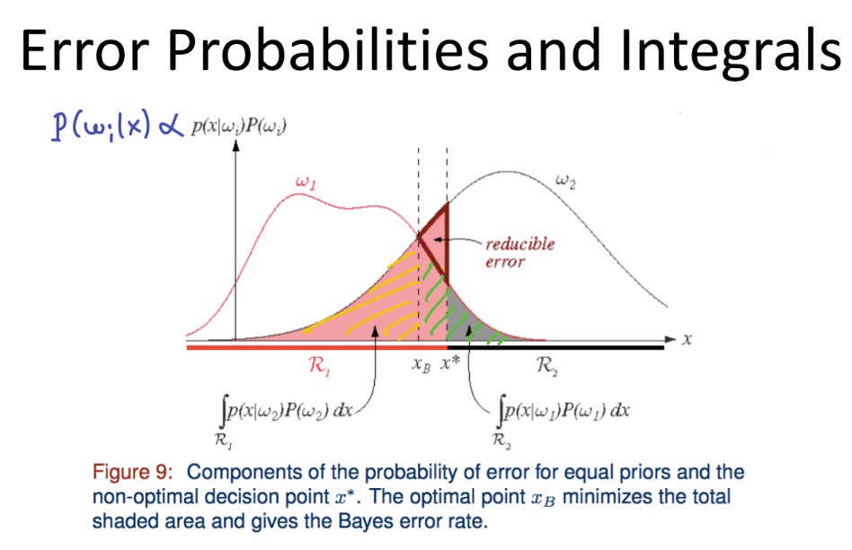
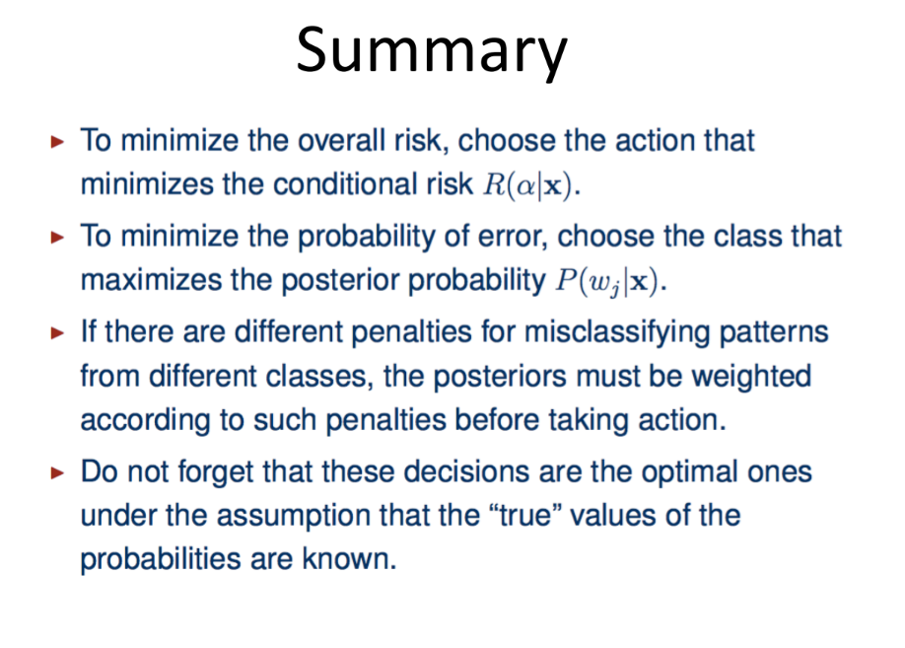

Feature Selection and Reduction
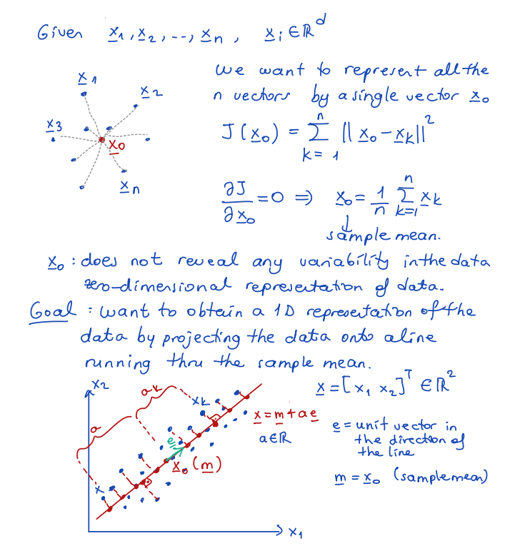
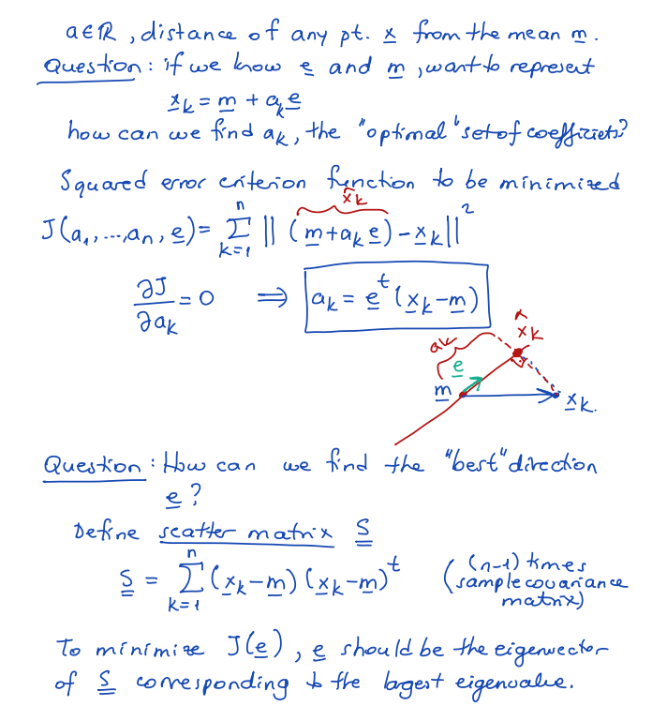
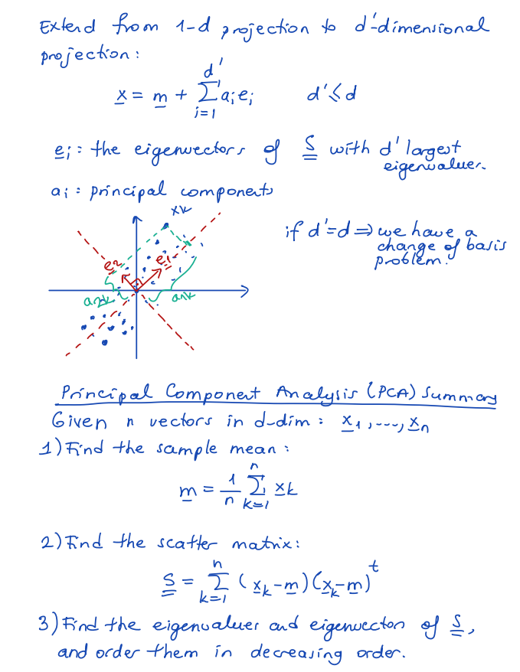
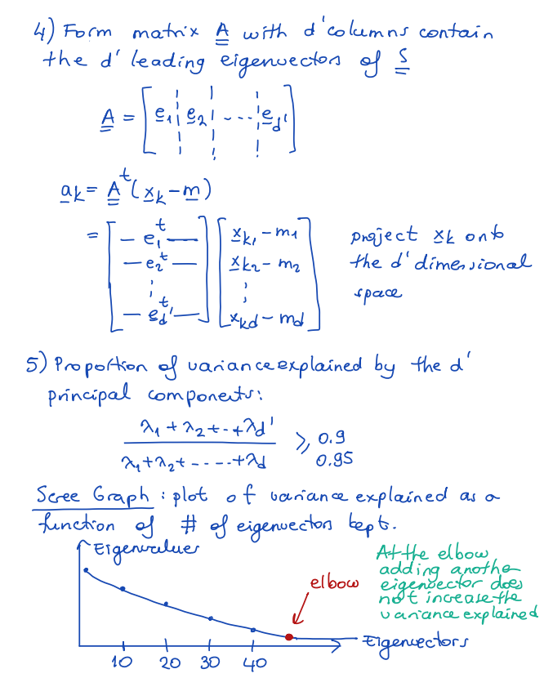
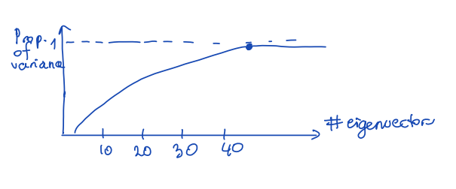

Linear Discriminant Analysis
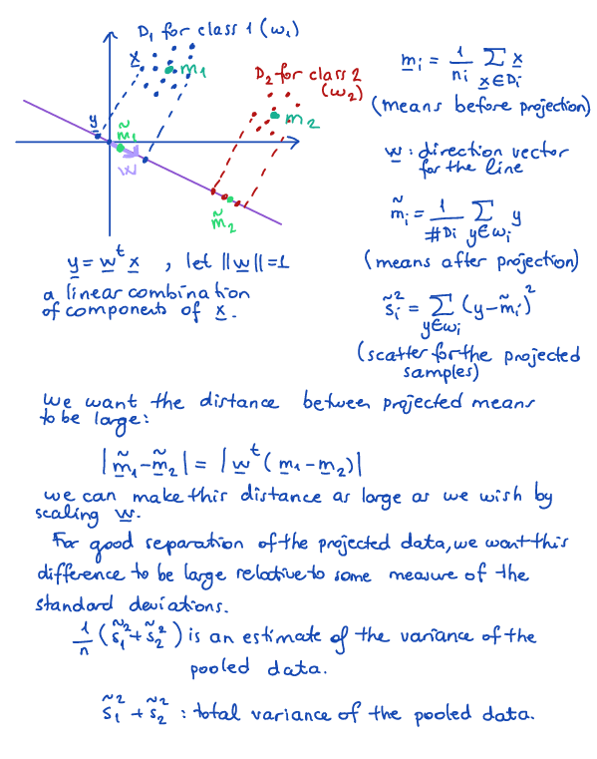
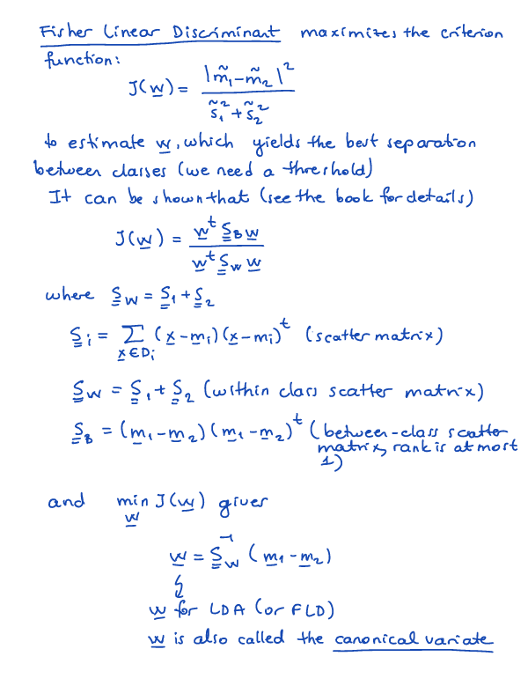

Feature Selection
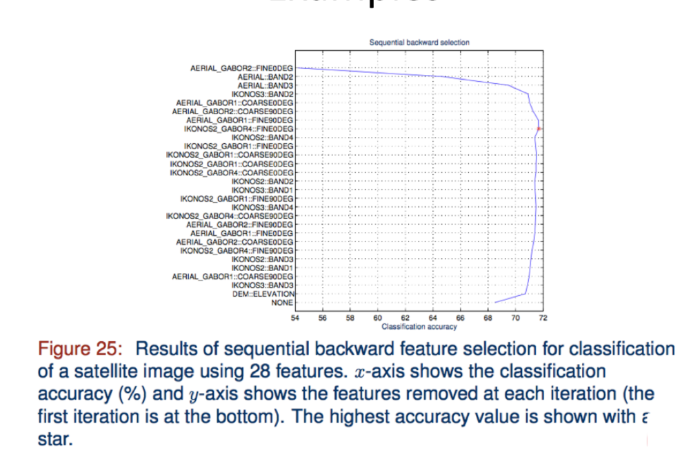
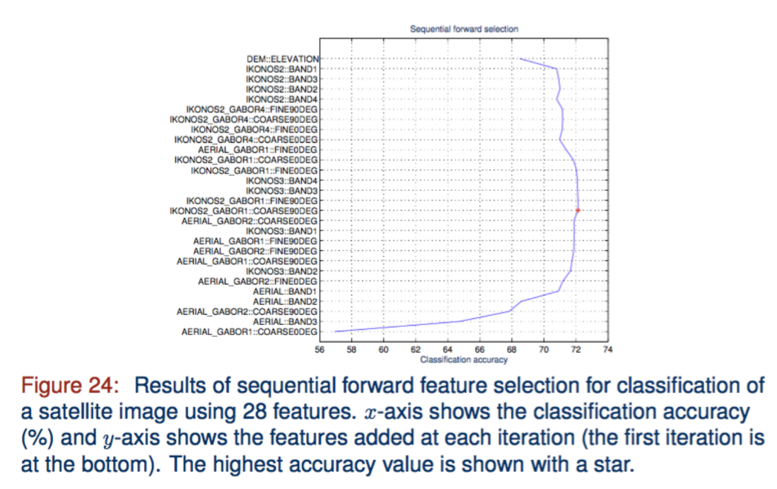

Naive Bayes Classifier
Read: https://www.geeksforgeeks.org/naive-bayes-classifiers/
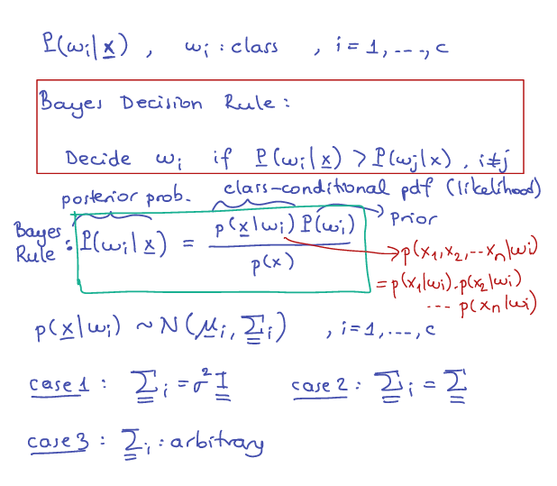
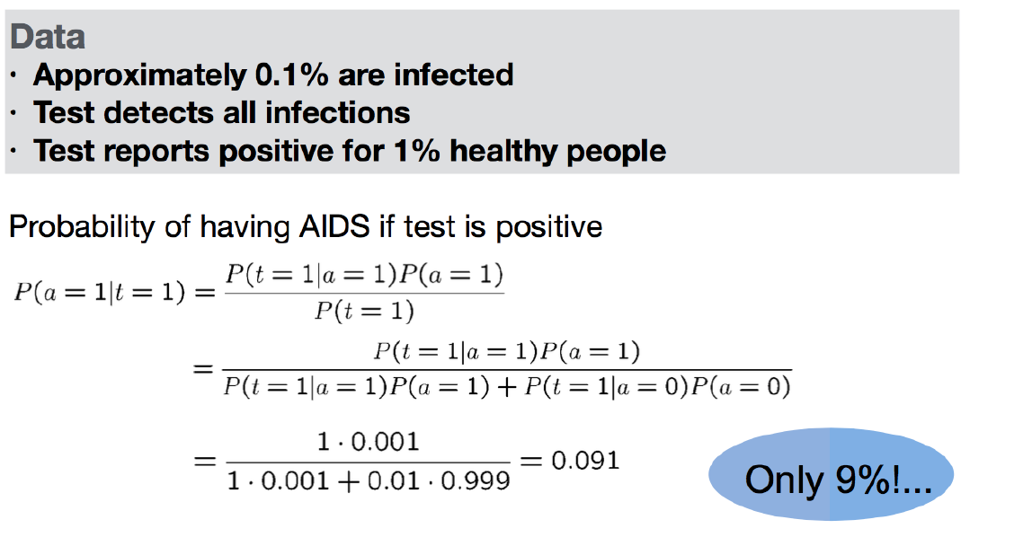
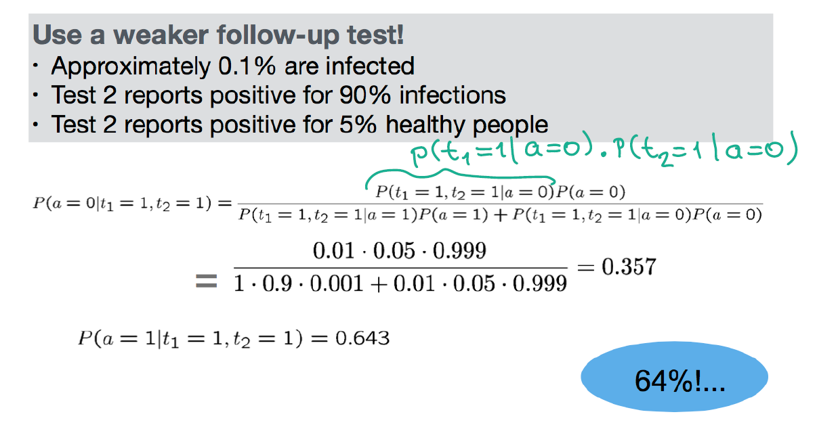
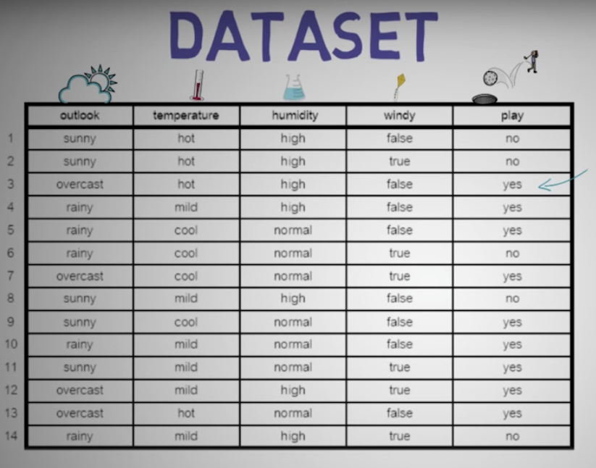
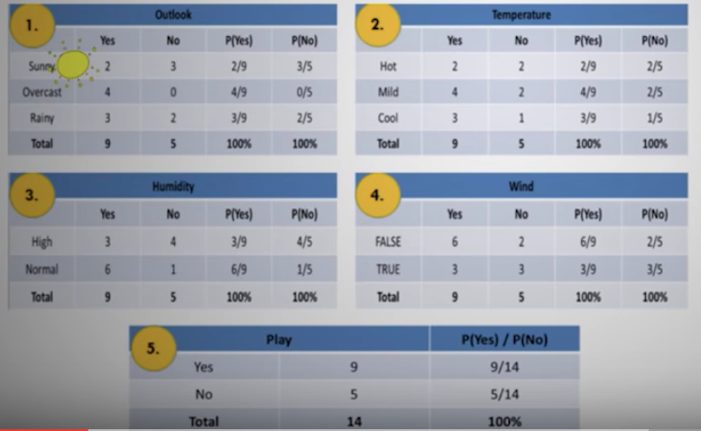
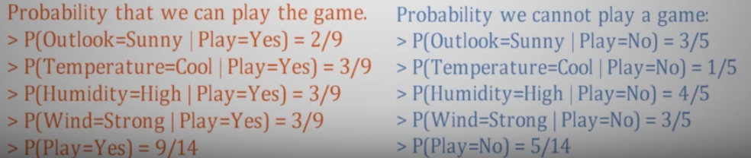
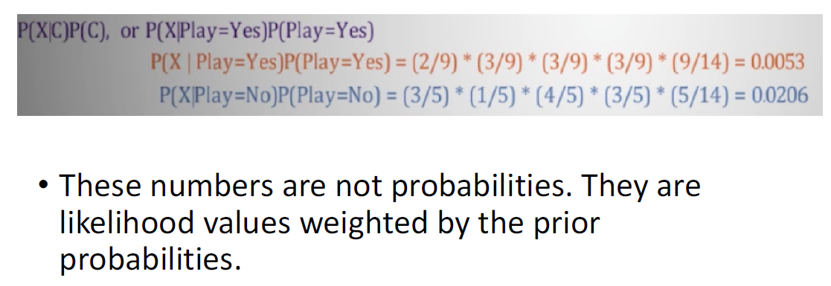
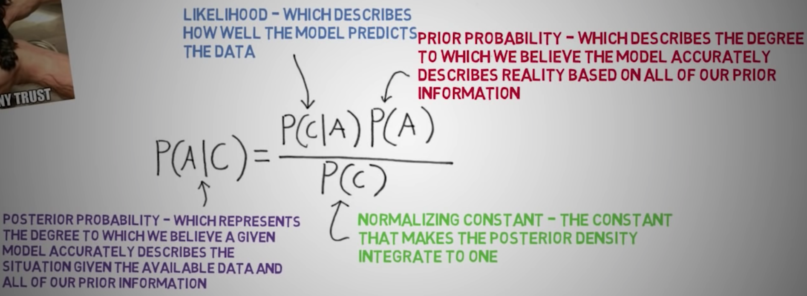
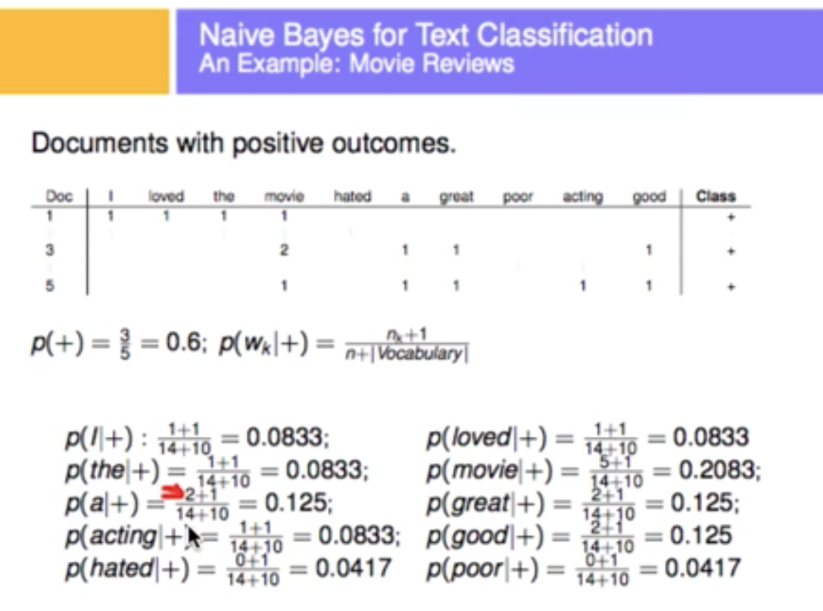
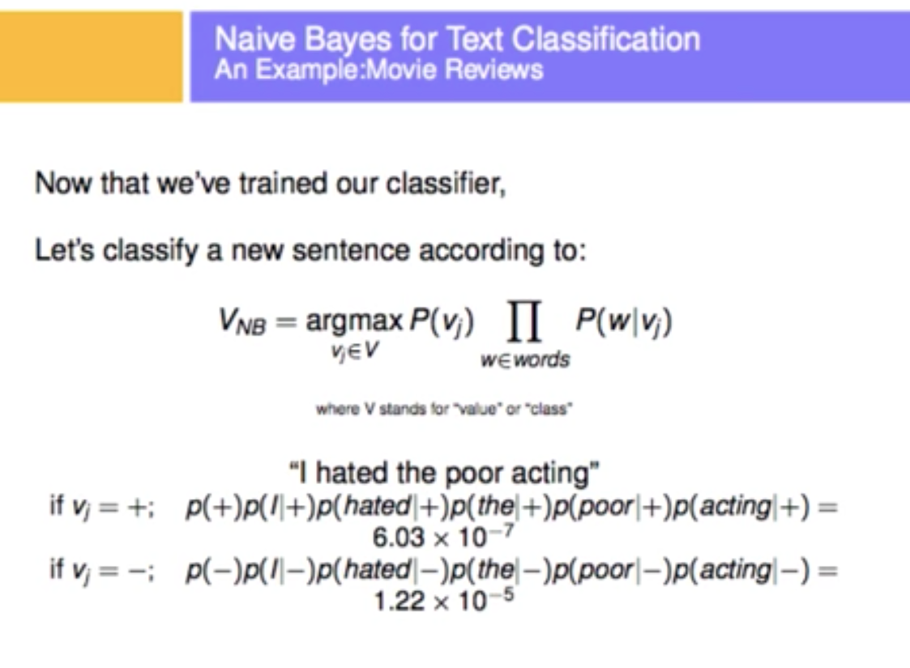

K-Nearest Neighbors (KNN)
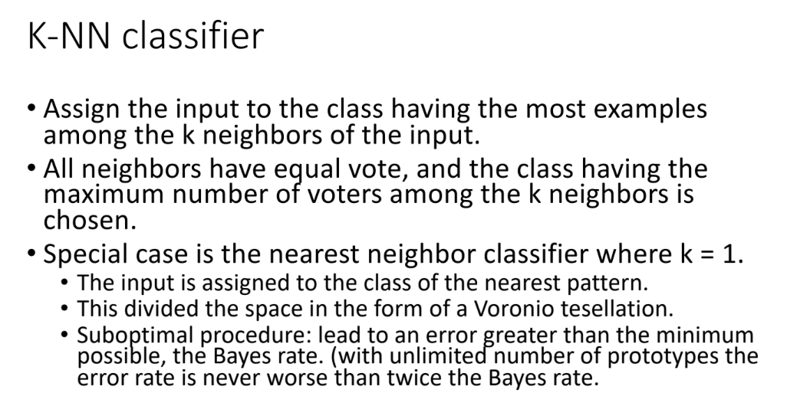

Decision Trees
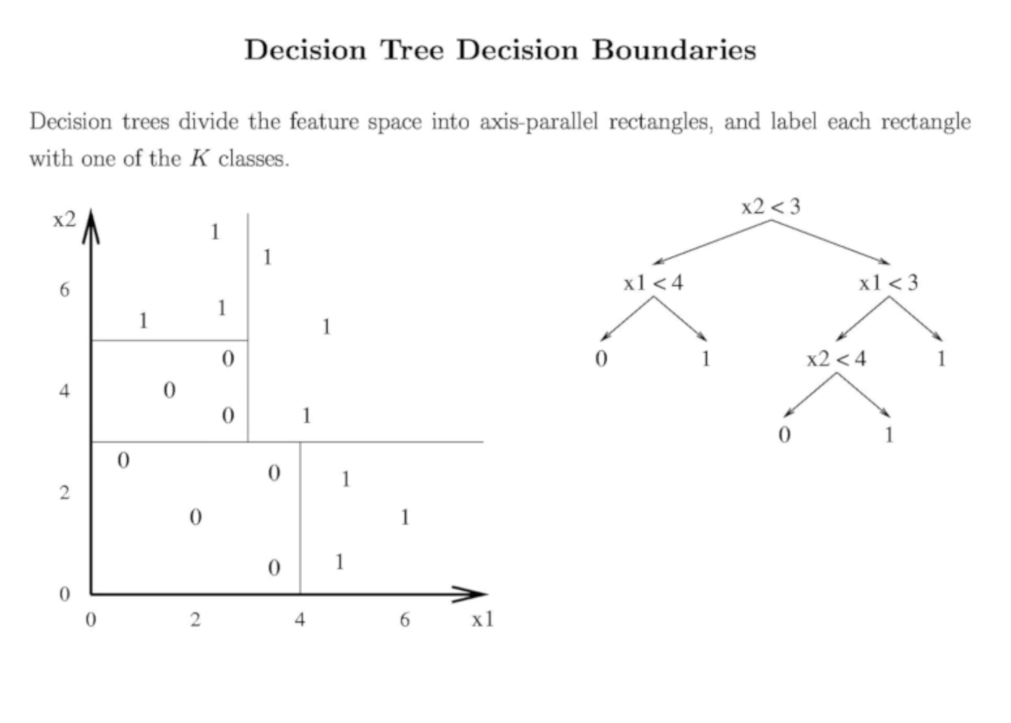
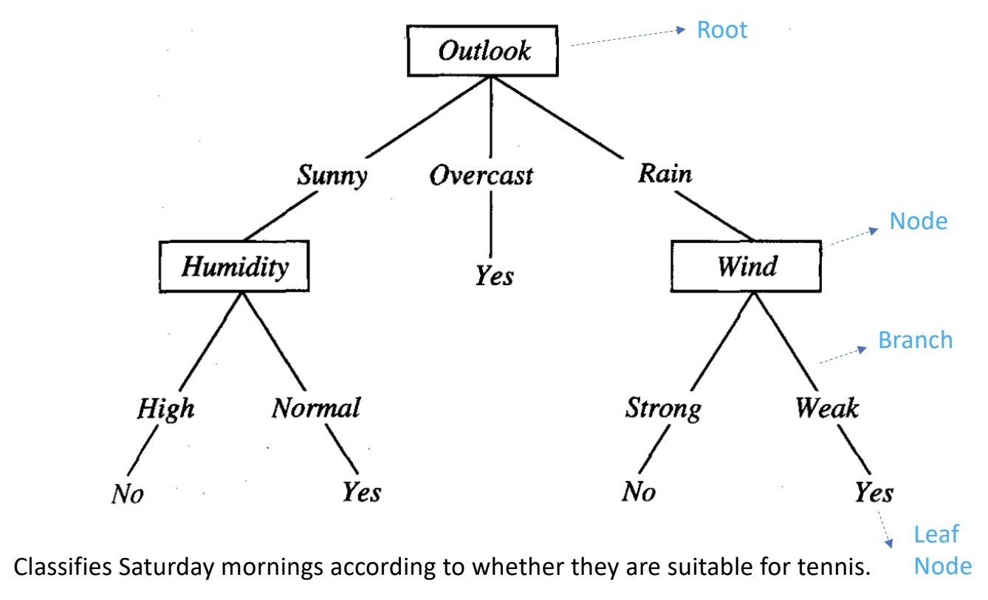

Entropy
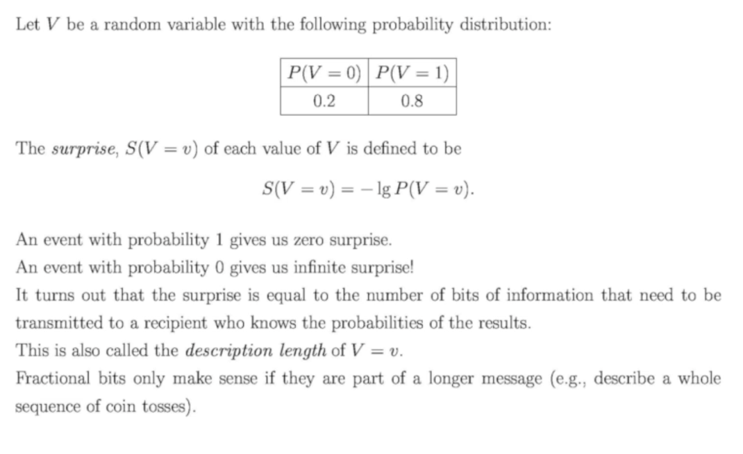
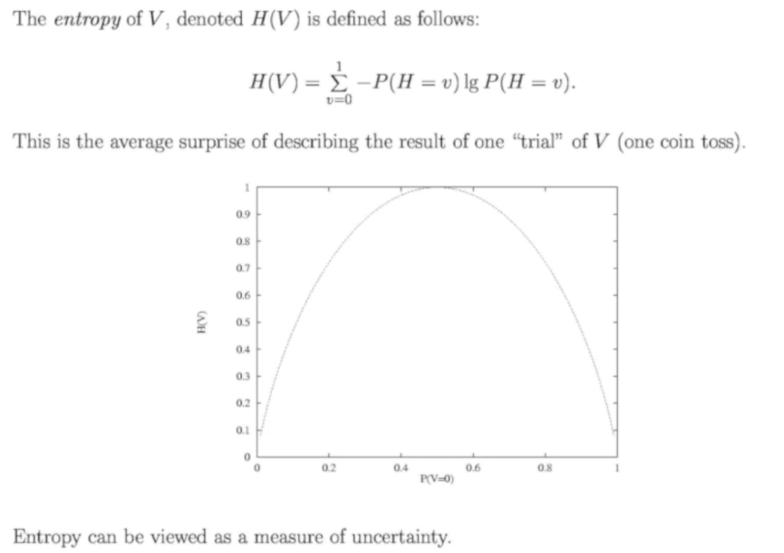

Example
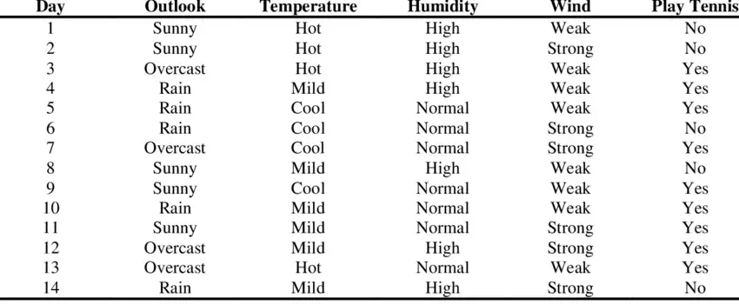
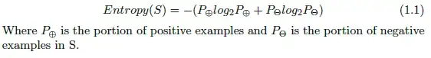
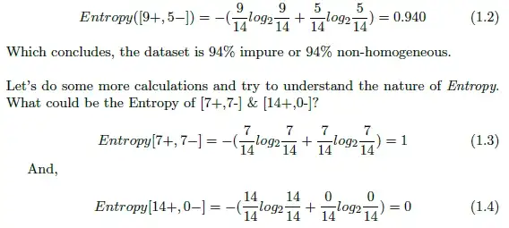
Further Read: https://medium.com/analytics-vidhya/entropy-calculation-information-gain-decision-tree-learning-771325d16f

Information Gain
Measure of effectiveness of an attribute in classifying training data
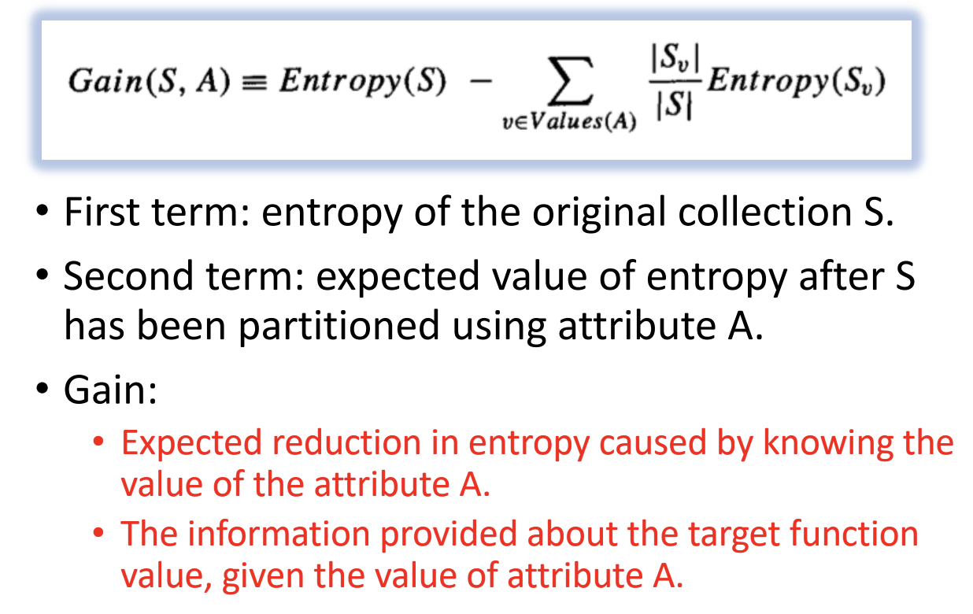
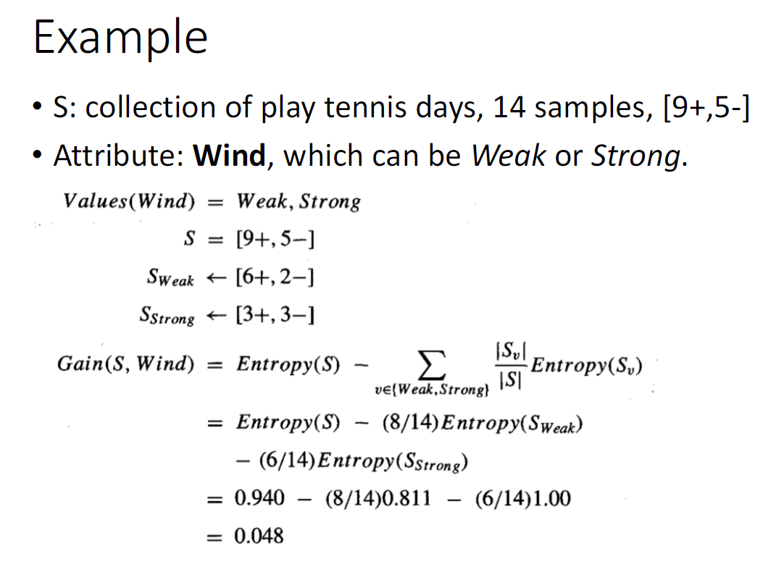

Clustering
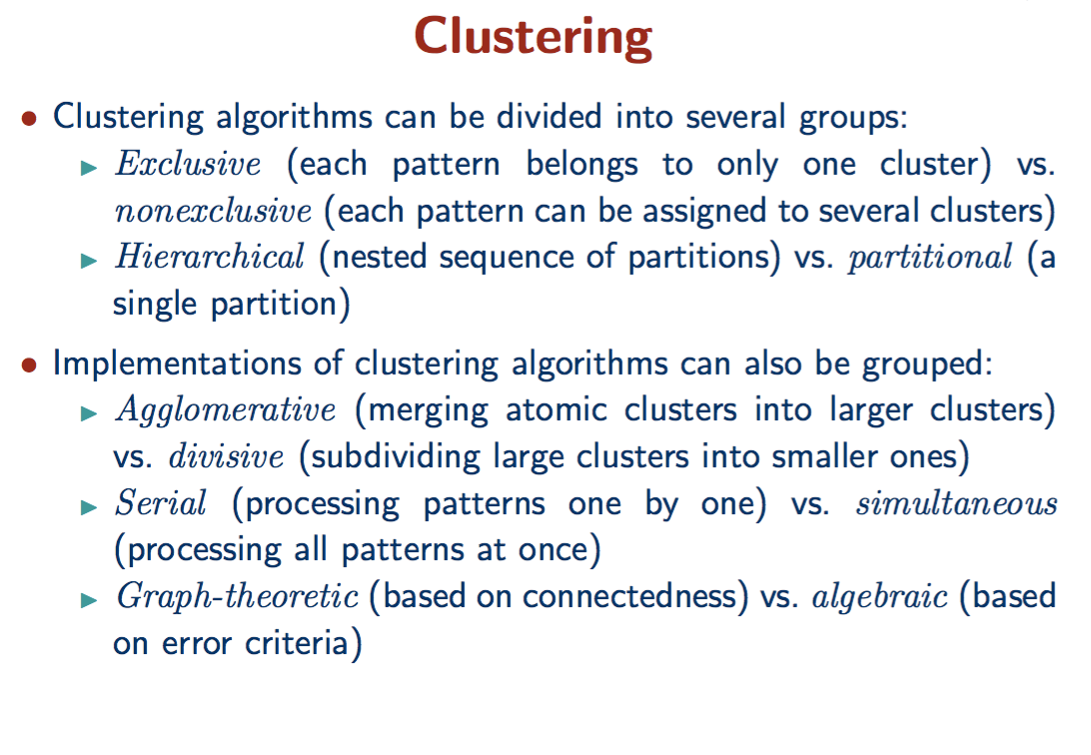
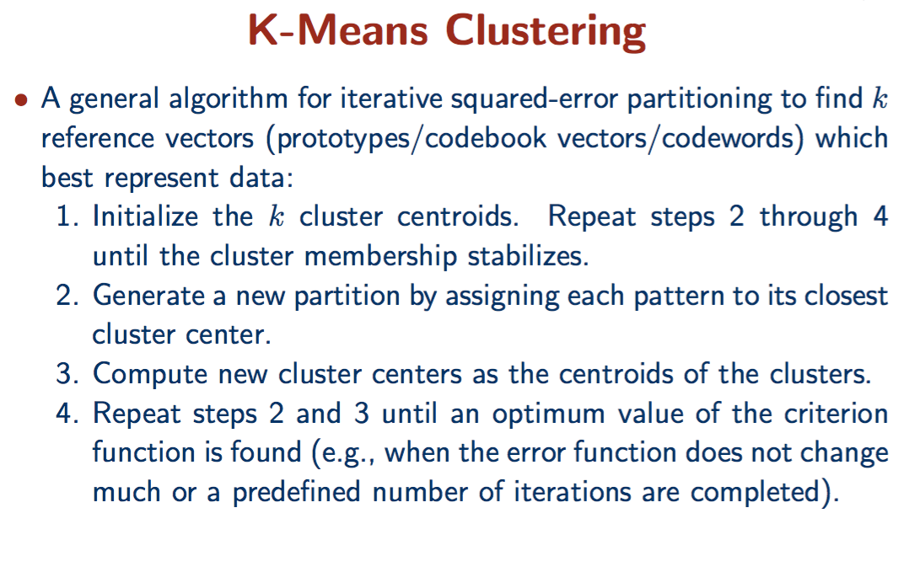
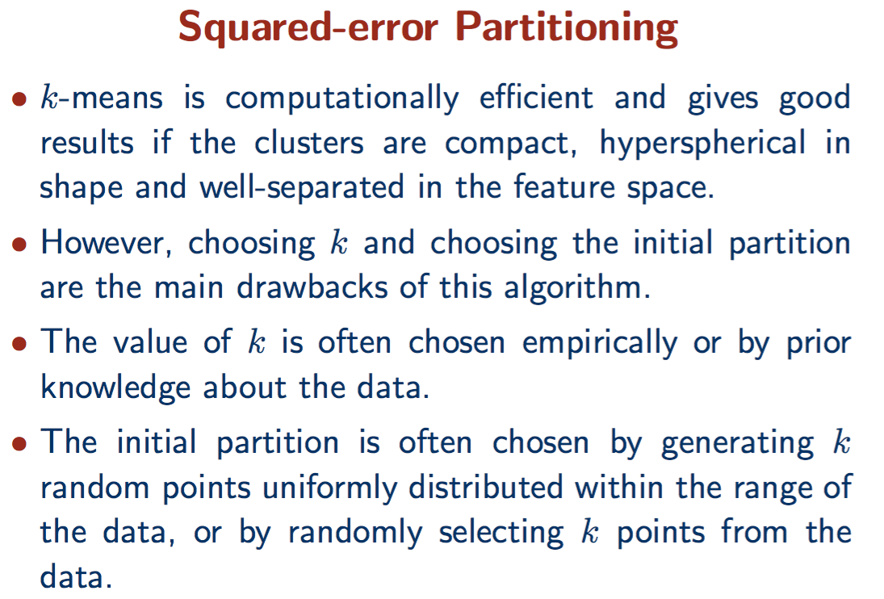
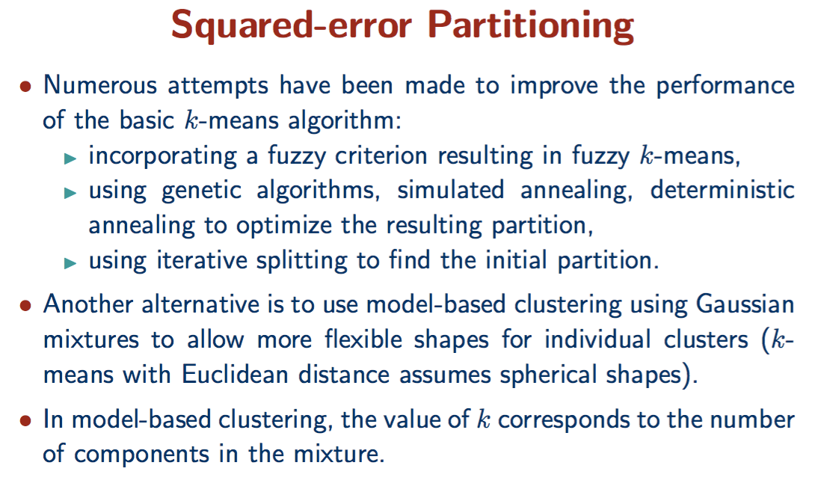
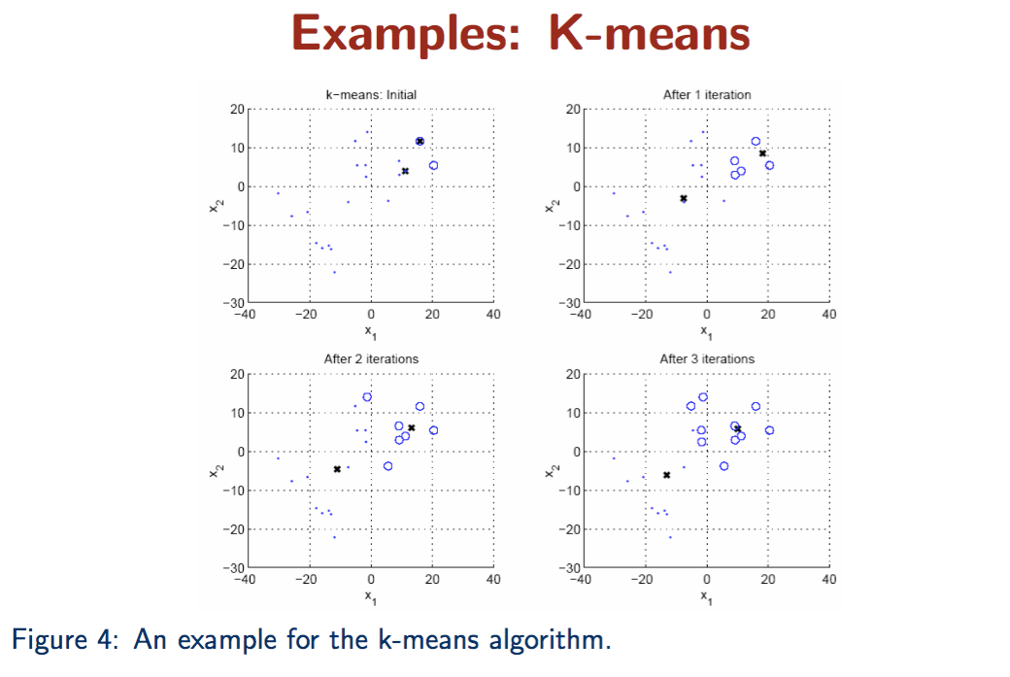
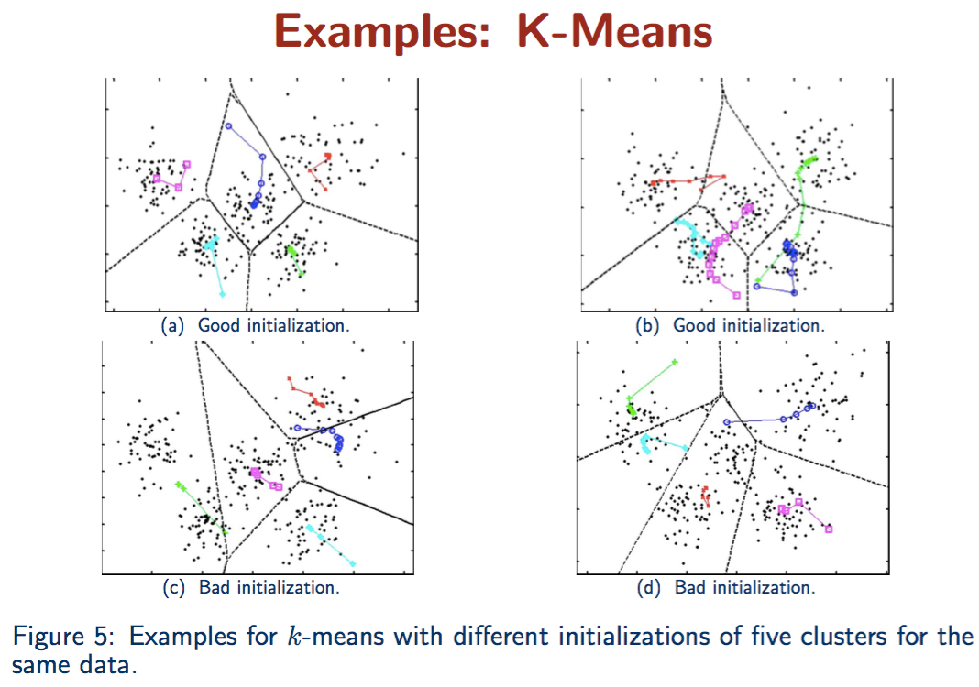
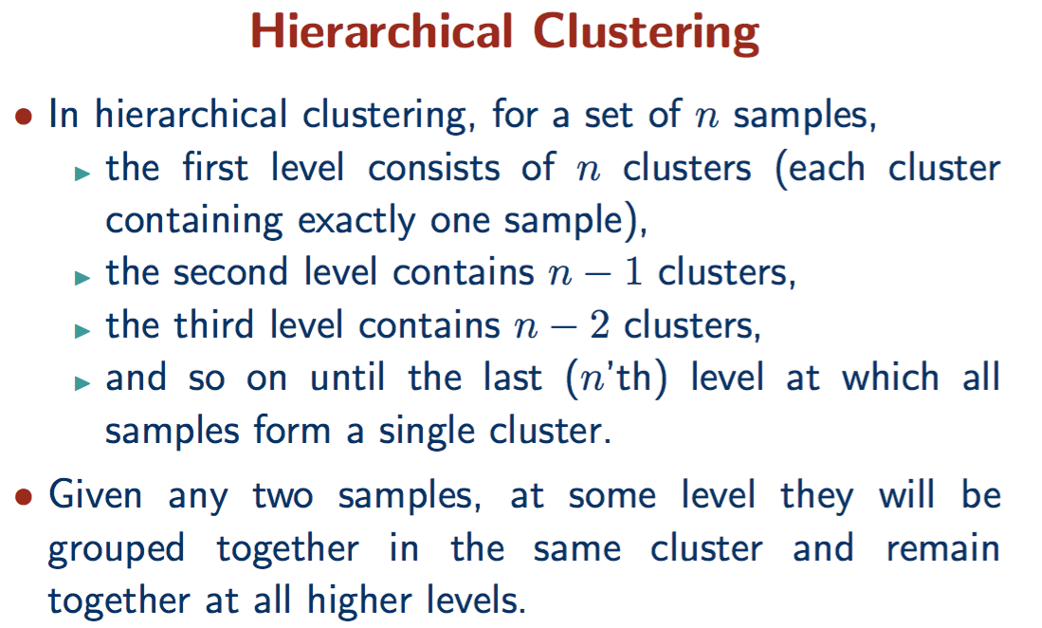
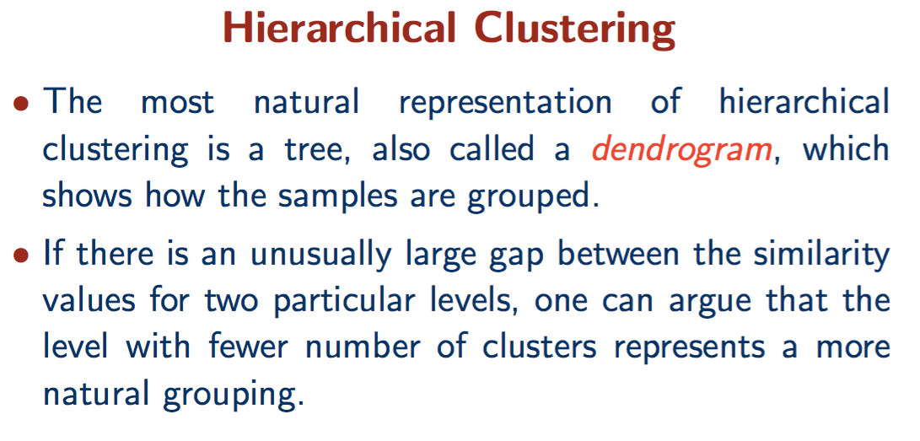
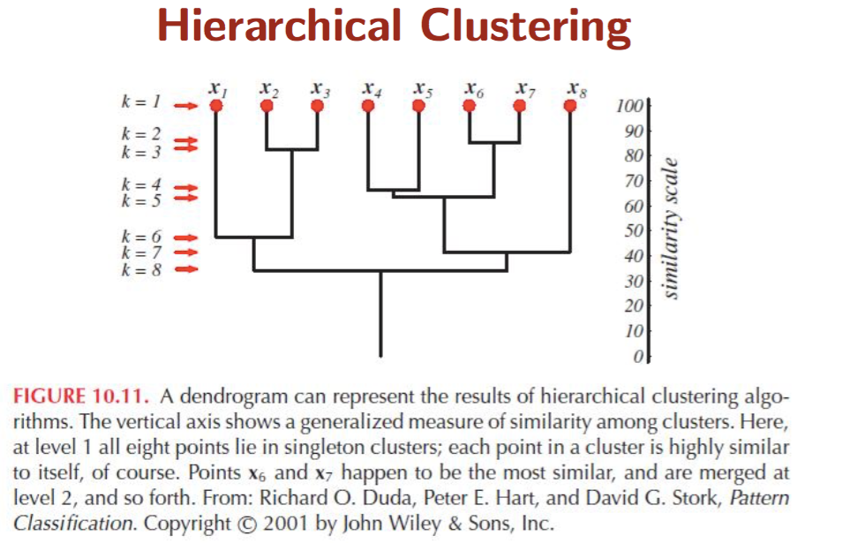

Evaluating Hypotheses

Confusion Matrix
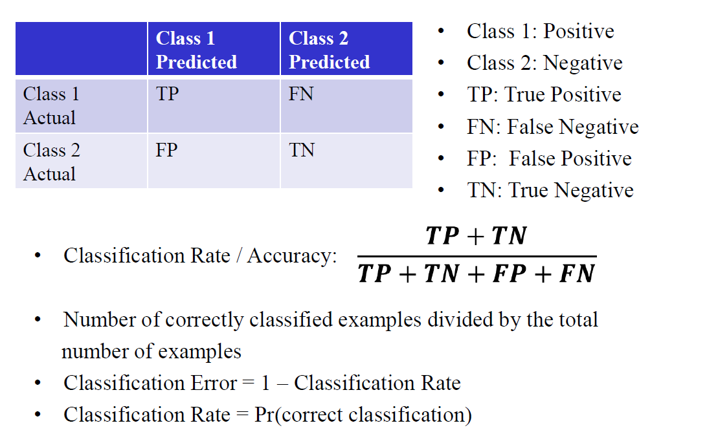

Recall
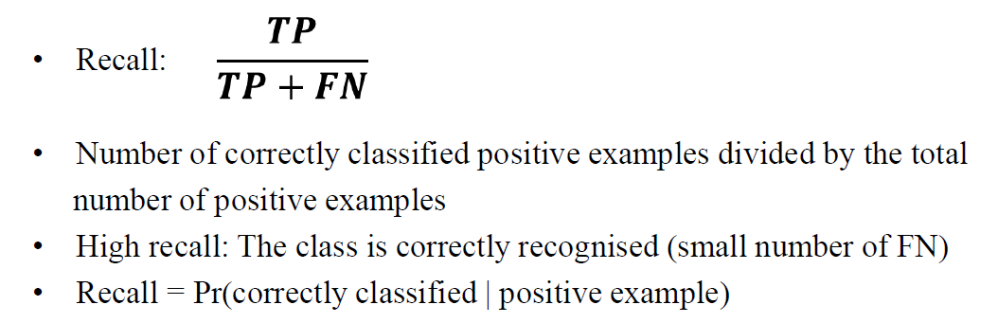

Precision
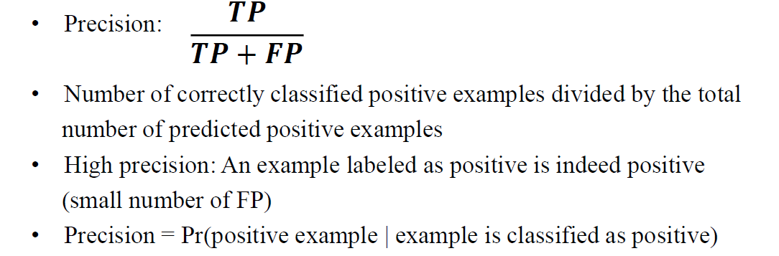
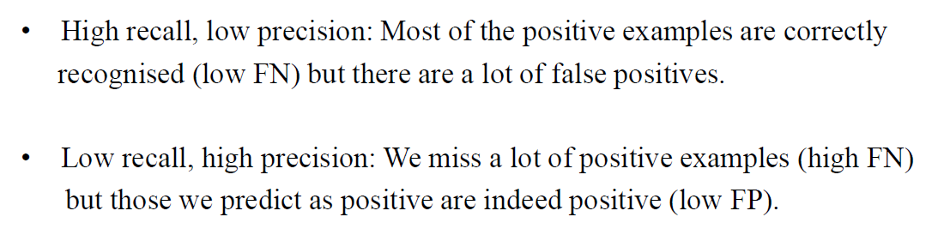

F1 Score
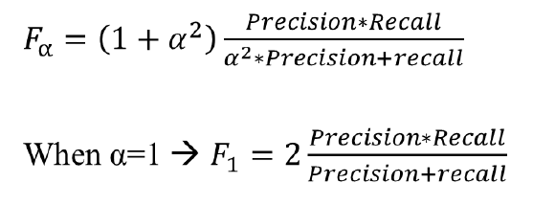

Training, Validation and Test Sets
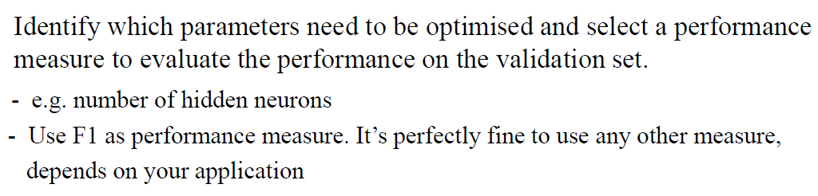
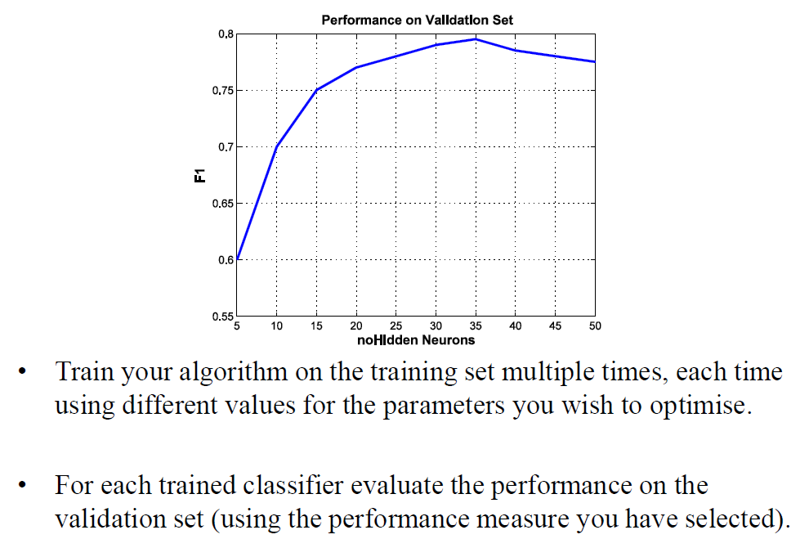
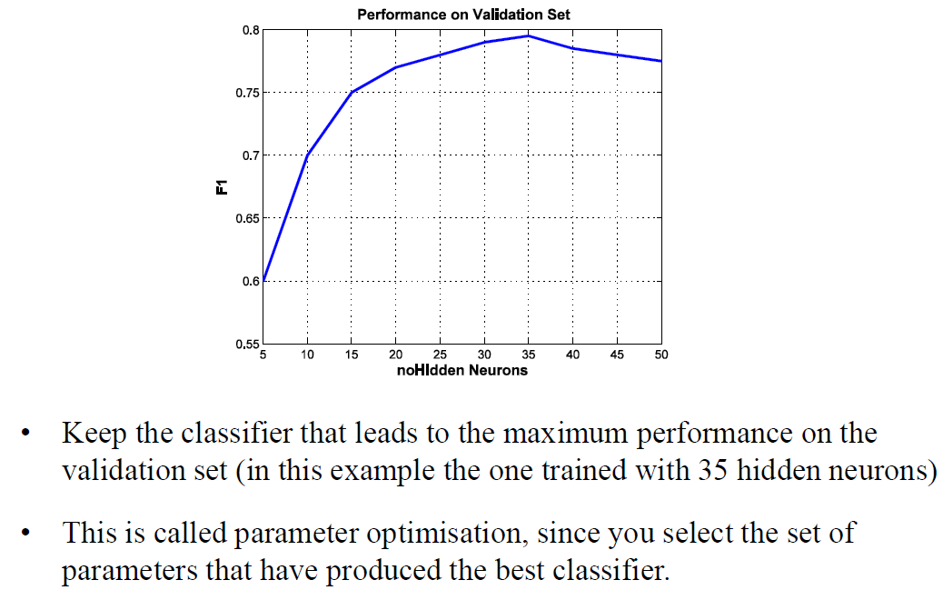
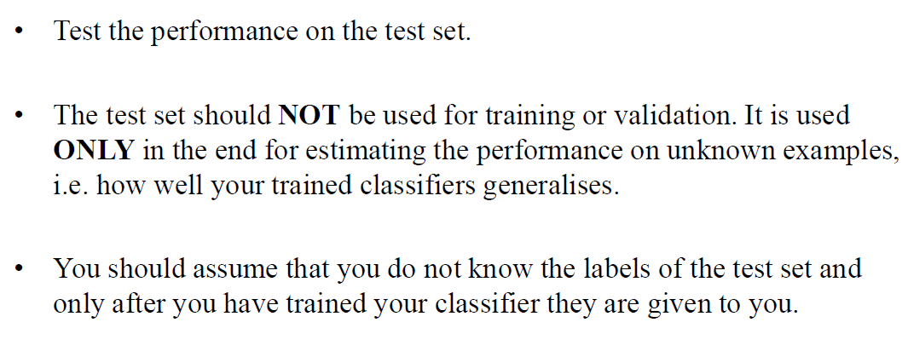

Cross Validation
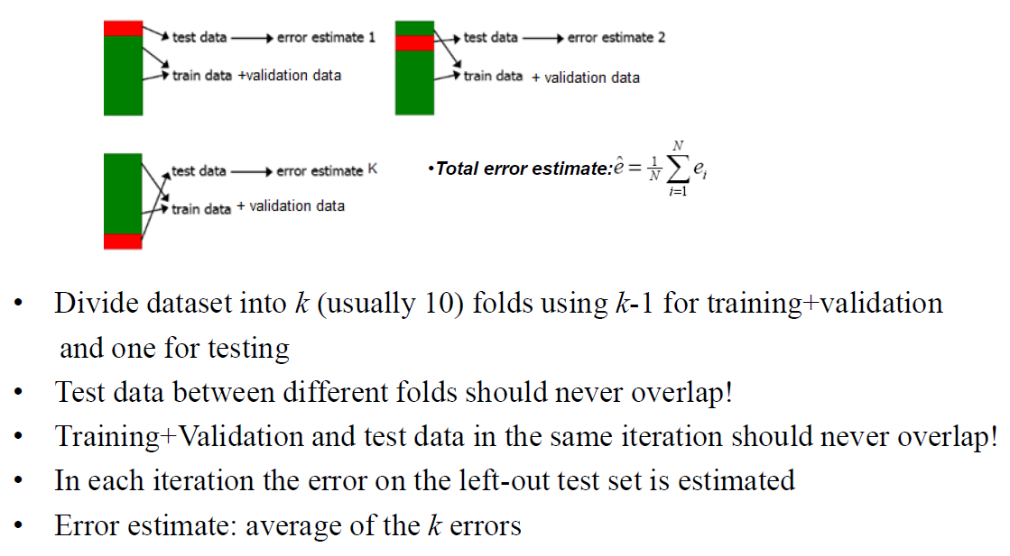
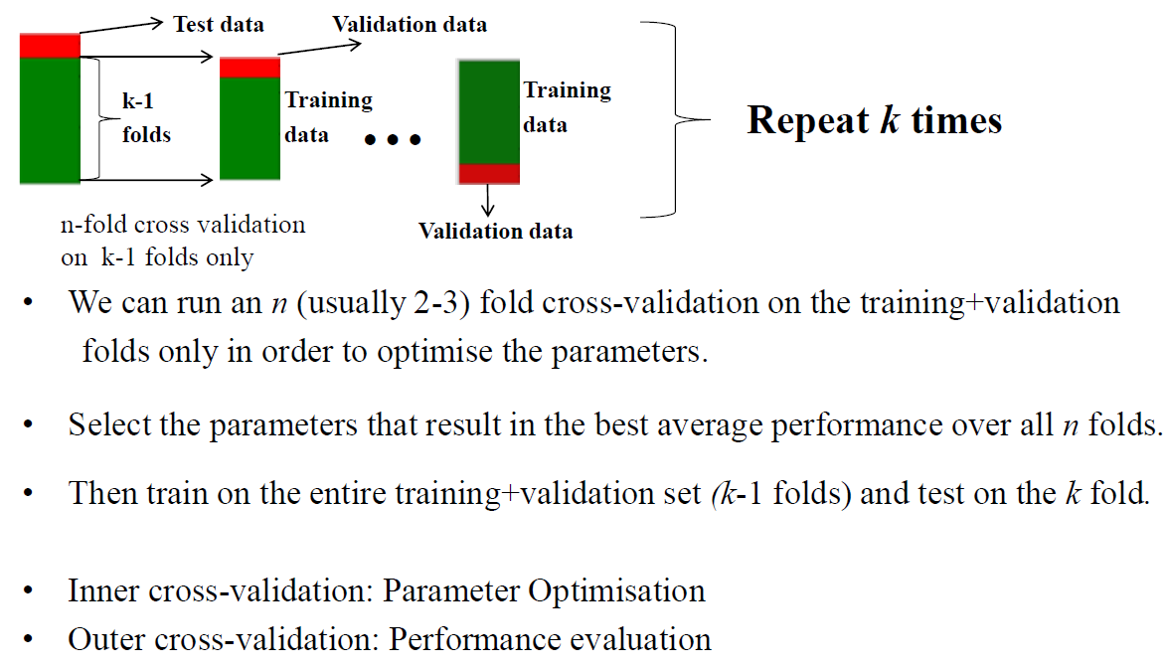
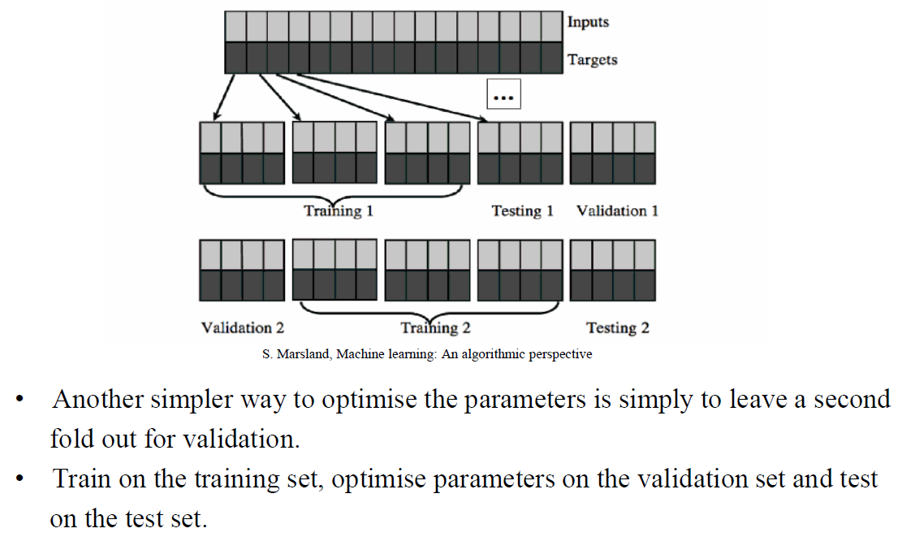

https://github.com/fatosmorina/machine-learning-exams

